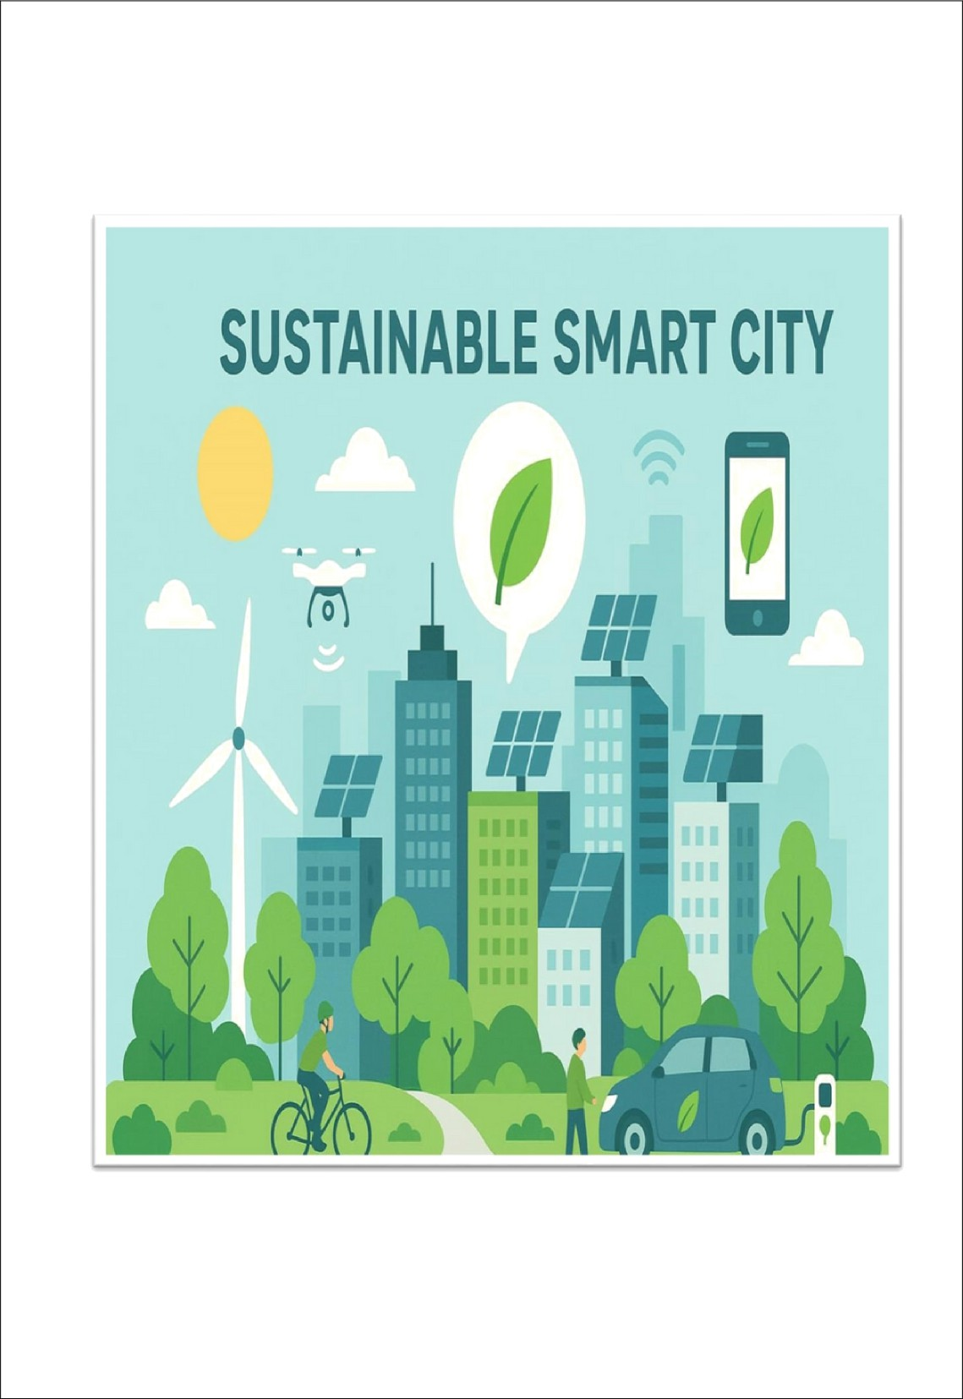Sustainable Smart City Assistant Using IBM

Granite LLM

# Team Members

* Salman Fasith.M
* Sanjay.K
* Sakthivel Murugan.M
* Sanjay Ram.J

# INTRODUCTION

TheSustainable Smart City Assistant using IBM Granite LLM is a generative AI-based project designed to support urban sustainability, governance, and citizen engagement by leveraging IBM Granite models from Hugging Face. The system provides quick tools such as a City Health Dashboard, citizen feedback collection, document summarization, and eco-friendly tips, thereby enabling smarter decision-making for city management. Implemented on Google Colab for easy deployment and powered by lightweight yet efficient Granite models, the project demonstrates how AI can enhance urban living through accessibility, scalability, and real-time insights, ultimately contributing to the vision of building smarter and more sustainable cities.

# PROJECT OVERVIEW

TheSustainableSmartCity Assistant leverages IBM Granite LLM models from Hugging Face to provide AI-powered tools for sustainable urban governance, citizen engagement, and environmental awareness. It supports features such as a City Health Dashboard, citizen feedback collection, document summarization, and eco- friendly tips. The project is designed to be lightweight and runs on Google Colab with Gradio UI for easy deployment and interaction.

# ARCHITECTURE

* 1. Frontend (User Interface)

Built using Gradio to provide an interactive web app.

Users can input queries, upload documents, and view dashboards.

* 1. Backend (Model & Processing Layer)

Powered by IBM Granite-3.2-2B-Instruct model from Hugging Face.

Handles text generation, summarization, and citizen engagement tasks.

* 1. Execution Environment

Deployed in Google Colab using T4 GPU for efficiency. Uses Python libraries: transformers, torch, gradio, PyPDF2.

* 1. Version Control & Deployment

Source code is stored and shared via GitHub repository.

# SETUP INSTRUCTIONS

* 1. OpenGoogleColab → create a new notebook.
  2. Change runtime to T4 GPU (Runtime → Change Runtime Type → GPU).
  3. Install dependencies:

!pip install transformers torch gradio PyPDF2 -q

* 1. Load IBM Granite model from Hugging Face (granite-3.2-2b- instruct).
  2. Run the provided application code (from Drive/GitHub).
  3. A Gradio link will be generated → open it to access the assistant.

# AUTHENTICATION

Hugging Face: Requires account login and access to IBM Granite model.

Google Colab: Uses your Google account for notebook execution. GitHub: Requires login for uploading/sharing project repository.

# USER INTERFACE

TheUI is powered byGradio:

Input box for user queries.

File upload option for document summarization. Interactive dashboard for city health indicators. Generated outputs displayed in real-time in another tab.

# TESTING

ModelTesting:Queries tested for sustainability-related responses.

Functional Testing: Verified file uploads, summaries, and feedback processing.

UI Testing: Ensured Gradio interface is responsive in browser. Performance Testing: Validated execution speed on T4 GPU.

# KNOW ISSUES

DependencyInstallation Errors in Colab if versions mismatch. Model Loading Delay when first initializing Granite LLM.

Limited Offline Usage since app relies on Colab cloud runtime. GPU Quotas in Colab may restrict extended usage.

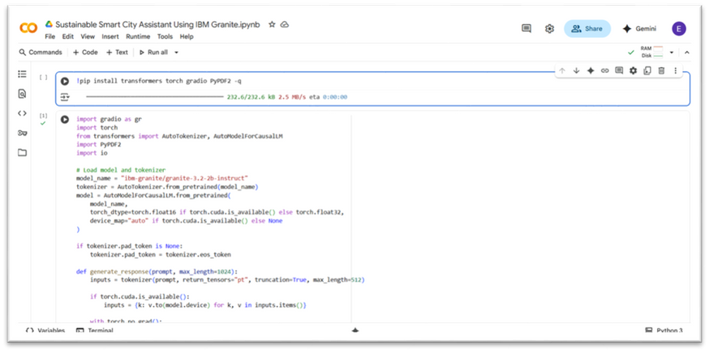

# FUTURE ENHANCEMENTS

Integration with real-time IoT data for city health monitoring. Deployment on cloud platforms (AWS, IBM Cloud, GCP) for scalability. Enhanced multi-language support for diverse citizen engagement.

Improved UI/UX with dashboards (charts, visual analytics). Adding voice-based interaction for accessibility.

Extending use cases to waste management, traffic optimization, and energy savings.

# PROJECT SCREENSHORT

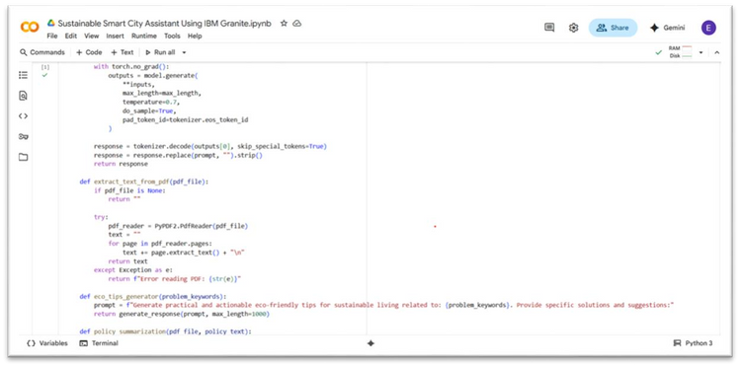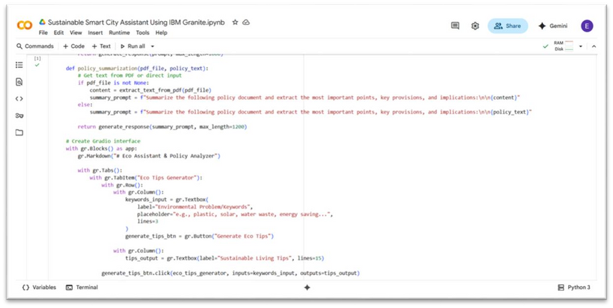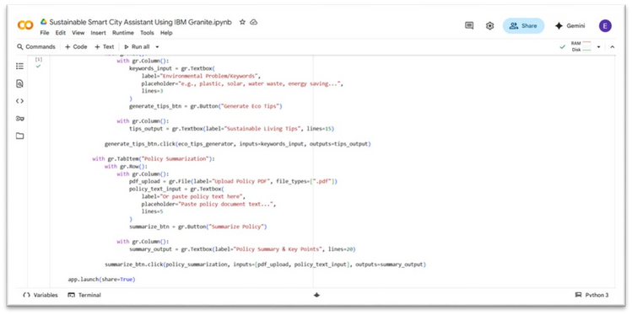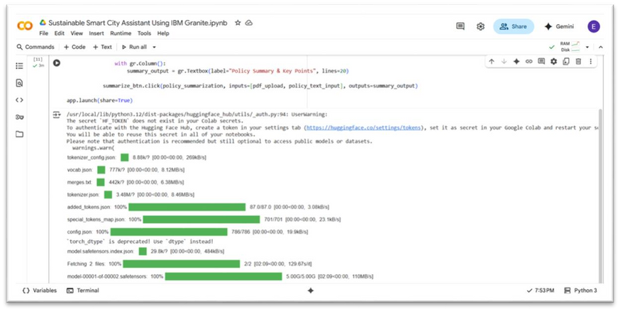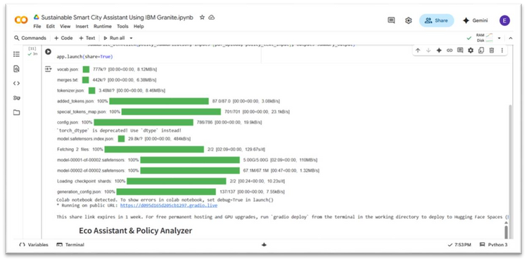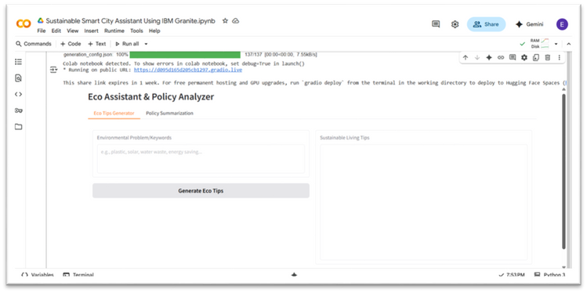

1. **CONCLUSION**

The sustainable smart city assistant using IMB granite LLM project was successfully done by: III BCA 2nd Sec, Salman Fasith.M,Sanjay.K, Sakthivel Murugan.M, Sanjay Ram.J

**Demo video link:** [https://drive.google.com/file/d/1va_QIPfonIHLTrnb7IqF162YTIO3AZz](https://drive.google.com/file/d/1ofaHpuZStvBOk9CSqLauz9nSEGn_0kL4/view?usp=drivesdk) [R/view?usp=sharing](https://drive.google.com/file/d/1ofaHpuZStvBOk9CSqLauz9nSEGn_0kL4/view?usp=drivesdk)